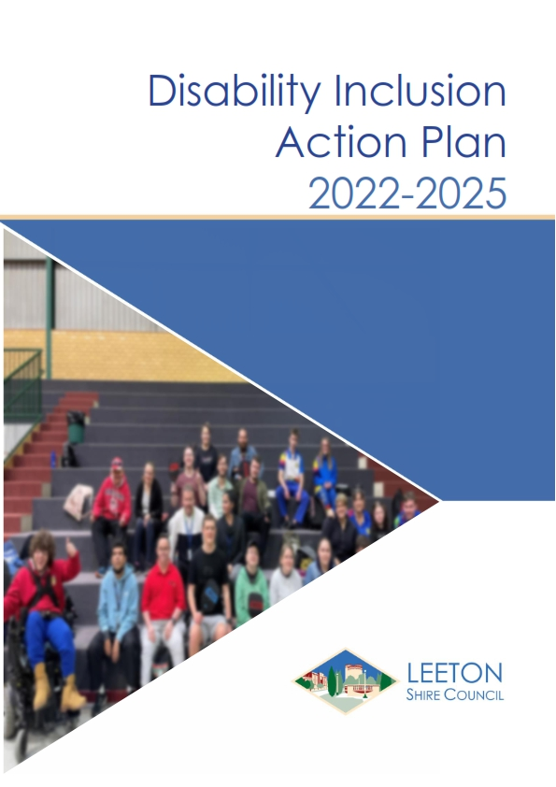
DOCUMENT CONTROL

RESPONSIBLE OFFICER: | Community Development Coordinator
REVIEWED BY: | Economic and Community Development Manager
LINK TO CSP/DELIVERY PROGRAM/OPERATIONAL PLAN: |  |  | Focus area 1 - A connected, inclusive and enriched community  C.c.1 We are friendly, inclusive and connected
DATE ADOPTED: |  |  | 09/11/2022
ADOPTED BY: |  |  | Leeton Shire Council
RESOLUTION NO: (IF RELEVANT): |  |  | 22/185
FOR PUBLICATION: |  |  | INTRANET COUNCIL WEBSITE BOTH
REVIEW DUE DATE: |  |  | 2026
REVISION NUMBER: |  |  | 2
PREVIOUS VERSIONS: | DATE | DESCRIPTION OF AMENDMENTS |  | AUTHOR/  EDITOR | REVIEW/ SIGN OFF | MINUTE NO  (IF RELEVANT)
 | 24/09/2017 | Original document |  |  |  | 17/023
 | 28/9/2022 | Review of document – for exhibition |  | EG
 | 9/11/2022 | Final DRAFT version to Council |  | EG |  | 22/185

REVIEW OF THIS DOCUMENT
This document will be reviewed every 4 years or as required in the event of legislative changes or operational requirements.
Any major amendments to the document must be made by way of a Council Resolution. Minor amendments such as corrections to spelling, changes to wording for improved clarity, formatting and updates to the Appendixes may be made without approval from the Council.
Acknowledgment of Traditional Custodians
Leeton Shire Council acknowledges and pays respect to the Wiradjuri people, the traditional custodians of the land encompassed by Leeton Shire.
Council also pays respect to the Elders, both past and present, of the Wiradjuri Nation and extend that respect to other Aboriginal and Torres Strait Islander people who live in Leeton Shire.
We recognise Aboriginal spiritual, social and cultural connections to these lands and waters and state our commitment to ensuring that Aboriginal rights, as enshrined in legislation, are upheld and not eroded.

Table of Contents
Statement of Commitment to Disability Inclusion from the Mayor and General Manager 5
Why do we have a Disability Inclusion Action Plan? 6
United Nations definition 7
Disability Discrimination Act (DDA) definition 7
Social Model of Disability 8
Barriers to Access and Inclusion 9
Community Profile 11
Report card on past performance 12
Stakeholder Engagement Process and Outcomes 13
Our Action Plan 16
Focus Area 1: Developing positive community attitudes and behaviours 16
Focus Area 2: Creating liveable communities 18
Focus Area 3: Supporting access to meaningful employment 21
Focus Area 4: Improving access to services 22
Delivering the DIAP 24
Governance 24
Integration 24
Monitoring and Evaluation 24
Reporting 24
Ongoing Engagement and Review 24
Funding the DIAP 25
Relationships to Council’s other plans 25
Laws and Systems 26

Statement of Commitment to Disability Inclusion from the Mayor and General Manager
Leeton Shire Council is proud to represent such a diverse, innovative and resilient community. We are committed to creating an environment where everyone feels welcome to participate and that their contributions are valued.
To this end, we are committed to working toward best practice in access and inclusion planning.
In implementing the Disability Inclusion Action Plan, Council recognises that it is the barriers that exist in community rather than disability itself that limit people’s ability to fully participate.
We also acknowledge that there are many types of disabilities and that they are not always visible. They may also be experienced alongside additional barriers to participation such as gender, age, sexuality, language, culture and resources.
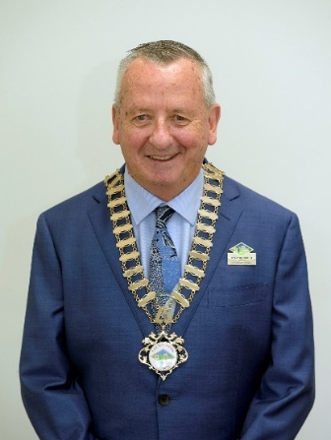
Cr Tony Reneker
MAYOR
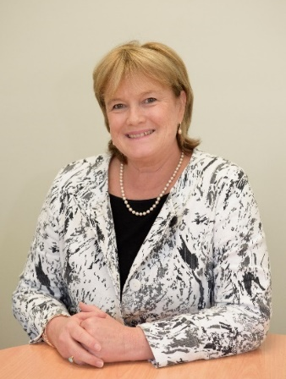
Mrs Jackie Kruger
GENERAL MANAGER

Why do we have a Disability Inclusion Action Plan?
In 2014 the NSW Government introduced the NSW Disability Inclusion Act 2014. The Act requires public authorities to have a Disability Inclusion Action Plan (DIAP) that shows what they are doing to enable people with disability to participate equally in their community.
The DIAP set out the measures Council intends to put in place (in relation with the exercise of our functions) so that people with disability can access general supports and services available in the community and can participate fully in the community.
The DIAP forms part of the Integrated Planning and Reporting (IP&R) framework which requires all NSW Councils to develop, document and report on plans for the future of their communities. The DIAP reports both to and from key corporate plans of Council such as the Delivery Program and the Community Strategic Plan.
This is the second DIAP developed by Leeton Shire Council.
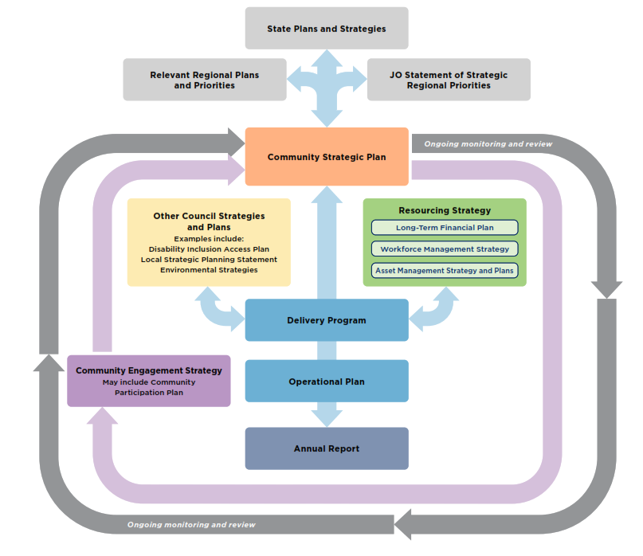Legal definition of disability
A disability is any condition that restricts a person’s mental, sensory or mobility functions. It may be caused by accident, trauma, genetics or disease.
It may be temporary or permanent, total or partial, lifelong or acquired, visible or invisible.
There are two official definitions of disability; the contemporary social definition provided by the United Nations Convention on the Rights of Persons with Disabilities and the national legal definition provided by the Disability Discrimination Act (DDA).
Both definitions aim to protect against discrimination and help all people to understand their rights and responsibilities.

United Nations definition
Australia is a signatory to the United Nations Convention on the Rights of Persons with Disabilities that defines disability as:
Persons with disabilities include those who have long-term physical, mental, intellectual, or sensory impairments, which in interaction with various barriers may hinder their full and effective participation in society on an equal basis with others.

Disability Discrimination Act (DDA) definition
The DDA legislation that protects Australians against discrimination based on disability provides a broad definition of disability including these eight types:
- Physical disability - Impacts mobility or dexterity.
- Intellectual disability - Impacts ability to learn or process information.
- Mental illness - Impacts thinking processes.
- Sensory disability - Impacts the ability to hear or see.
- Neurological disability - Impacts the brain and central nervous system.
- Learning disability - Impacts acquisition, organisation, retention, and understanding of information.
- Physical disfigurement - Impacts physical appearance.
- Immunological disability - Impact due to the presence of organisms causing disease in the body.

Social Model of Disability
The old way of thinking about disability focused on an individual’s impairment as a medical condition to be treated, fixed, or cured.
Fortunately, in recent times there has been a shift in the way disability is viewed and understood. The focus is now on the interaction with their environment.
Disability arises from the way people with disability interact with the world. Individuals encounter physical barriers, digital barriers and barriers of attitudes and communication. These barriers impact on an individual’s ability to equitably participate in society.
This shift in perspective takes into consideration that disability can be exacerbated by an environment that creates barriers. The focus is on removing barriers and implementing adjustments that provide an equitable experience for people with disability.
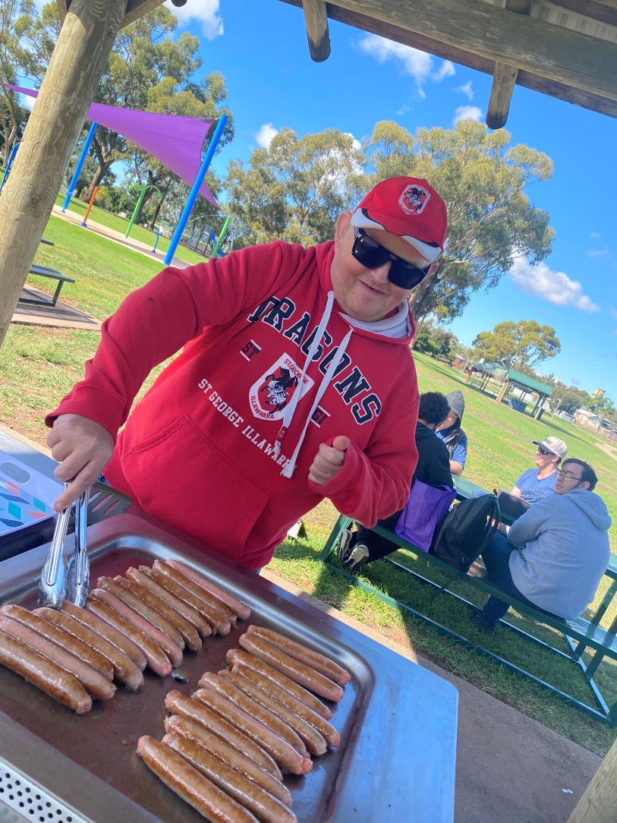
Photo courtesy of Kurrajong

Barriers to Access and Inclusion
People with disability face many and varied barriers. Staff at all levels and across functions need to have some understanding of the types of barriers and how they might impact people with different disabilities and take this into account when undertaking Council work.
The three primary types of barriers are:
- Attitudinal Barriers (people)
This is the most common experienced barrier and often the most difficult to address. It comes about through misunderstanding what it means to have a disability and how it might impact on someone’s life.
It is often characterised by a range of negative stereotypes and assumptions about a person’s capacity, abilities and entitlement to belong, participate and contribute.
When it is experienced by people with disability, its impact can be severe and profound. It can result in people being made to feel different, unworthy and not belonging and ultimately to be excluded from participating in community life.
Working to reduce the attitudinal barrier is primarily about awareness raising through education and training initiatives.

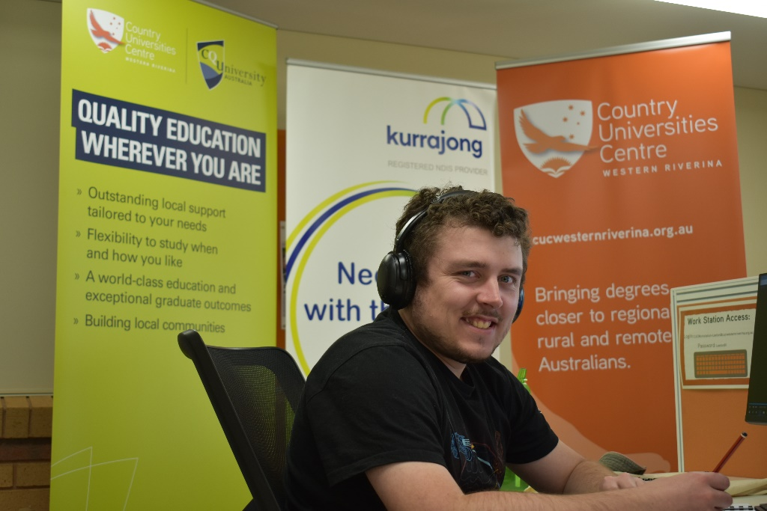
Photo courtesy of Kurrajong

- Physical Barriers (places)
A common misunderstanding is that inclusion for people with disability is only about the built environment. Physical barriers and obstacles can limit a person’s capacity to move independently in the environment in a safe and dignified manner. Physical barriers can result in people with disability experiencing challenges accessing the built environment or total exclusion.
Working to reduce the physical barriers is primarily about ensuring that built infrastructure is designed, constructed and maintained in a manner that allows ease of access for all manners of physical disability. This includes installation of augmentation strategies such as hearing augmentation, development of websites in accord with Web Content Accessibility Guidelines (WCAG 2.1 Level AA) standard and so forth.
- Procedural Barriers (policies)
Policies and Procedures can present unfair or unreasonable barriers for people with disability. The impact of a disability is unique for every person and every person’s capacity to deal with the impact will also vary. As a result, people with a disability often need to do things in a different way to others.
Working to reduce procedural barriers is about ensuring that policies and procedures take such differences into account and are flexible enough to cater to necessary, reasonable adjustments and accommodations that may be required. This will ensure that disability access and inclusion become an integrated part of the mainstream way of doing things. Initiatives to reduce attitudinal and physical barriers will also assist.
Inclusion is intentional.
It is about identifying and removing barriers so that everyone can participate to the best of their ability.

Community Profile
Leeton is located 6 hours’ drive from Sydney, 5 hours’ drive from Melbourne, 4 hours’ drive from Canberra, 45 minutes’ drive to Griffith and 1 hour 20 minutes’ drive to Wagga Wagga.
These distances have bearing for people with a disability who may need to see specialists, attend medical appointments, or access other support services.
According to the Australian Bureau of Statistics 2021 census on Population and Housing for Leeton Shire:
- 712 persons stated that they needed assistance with core activities which represents 6.2% of the Shire population.
- 1077 persons over the age of 15 years stated that they are providing unpaid assistance to person with a disability. This represents 11.9% of the population.
Additional information from the Public Health Information Development Unit of Torrens University of Australia titled Social Health Atlas of Australia Data by Local Government Area (July 2022) states that in Leeton Shire:
- 392 persons receive a disability support pension representing 5.9% of the population aged 16 to 64 years of age.
- 1345 people receive an age pension (65.2% of people over 65 years of age.
- 14 people receive a Department of Veterans Affairs pension representing 0.5% of the Shire population aged over 60 years of age.
- 500 people have a profound or severe disability (includes people in long term accommodation) representing 4.8% of whole Shire population.
- The table below details the number of Leeton residents who live with different illness/conditions.
Illness or condition | Number of people in Leeton Shire
Asthma | 1296
Mental health condition | 1064
Long-term health condition | 791
Arthritis | 1121
Cancer | 299
Dementia | 98
Diabetes | 569
Heart disease | 427
Kidney disease | 128
Lung condition | 286
Stroke | 98

Report card on past performance
The following is some of the achievements since the adoption of the 2017 DIAP. This list is not exhaustive but highlights key achievements.
- Refurbishment at the Leeton Regional Aquatic Centre to include a compliant ramp into the Olympic pool with aquatic wheelchairs, an adult changing hoist installed in the changeroom and beach entry into the learn to swim pool.
- Disability access ramp and automatic doors installed at Leeton Museum and Art Gallery entrance and a new disabled parking space installed.
- Upgrade of Wade Ave improved footpath surfaces, crossing facilities and the disabled parking.
- Installation of three automatic opening doors within the Council main office.
- Increased the network of footpaths and cycleways by 2.4km. Total network now 42km.
- Partnered with MyPlan Connect to create the Lands Office Café barista training program.
- Promoted free Auslan Tutor computer application to celebrate International Day of Sign Language.
- Offered free home library service to residents and carers who live with disability.
- New Council website platform that meets Web Content Accessibility Guidelines WCAG 2.1 Level AA.
- ‘Come and try Pickle ball’ run by Council’s Recreation Facilities & Program Coordinator at the Stadium for Kurrajong (Leeton, Narrandera and Griffith), Gralee School and MyPlan Connect. It resulted in ongoing bookings of the stadium by Kurrajong and Gralee School.

Stakeholder Engagement Process and Outcomes
Council’s Community Development Coordinator conducted the stakeholder engagement process. The approach targeted two separate groups of stakeholders - internal (Council staff) and external (Community).
Staff, allocated actions in the 2017 DIAP, were interviewed one-on-one or in small teams to review progress and identify issues and opportunities.
A staff survey was conducted to measure the level of understanding of the DIAP, disability awareness and the efforts Council was doing to improve the lives of people with disability. 47 responses were received.
A community survey was issued. It was direct e-mailed to 740 residents registered in Council’s ‘Have your say’ database. It was also promoted on social media and by placing posters in key locations. The posters used a QR code to take respondents to the survey. It was also promoted through local disability providers networks. Hard copies were available at Council and the library. 24 community responses were received.
Valuable feedback came from discussions with people with lived experience of disability in Leeton Shire.
Interviews were conducted with the following:
- Kurrajong Manager (Leeton)
- MyPlan Connect Directors
- Gralee School Principal
- CVGT employment
- Holistic Support Network
- Community Transport
- Five residents
A workshop was held with Griffith Post School Options GPSO (Leeton) participants. Seven participants and their support workers participated in the discussion to communicate what is and is not working in Leeton Shire.

Some of the key outcomes from the engagement process were:
- The desire for the Disability & Inclusion Reference Group to be re-established by Council staff and the community
- Lack of accessibility into local shops
- The need to build staff and community awareness around disability
- Barriers around transport – taxi, community transport, footpaths
- The need for independent living options in Leeton so people can stay closer to their families
- The need for an adult change facility
- Keeping the DIAP ‘front of mind’ for Council staff
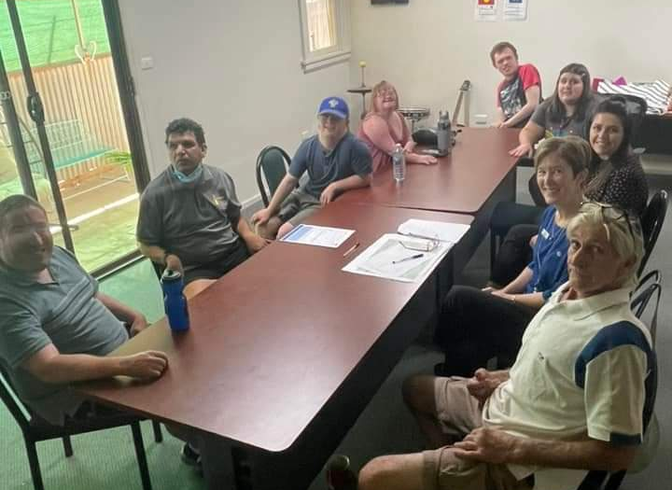

The information collected from the stakeholder engagement process has informed the action plan.
Actions have been grouped under the four focus areas outlined within the NSW Disability Act as being of primary importance in creating an inclusive community. This will also assist when reporting progress on the DIAP.
The four focus areas are:
- Developing positive community attitudes and behaviours
- Creating liveable communities
- Supporting access to meaningful employment
- Improving access to mainstream services through better systems and processes.
Actions have been assigned to a Council staff member to ensure accountability. The action plan also identifies staff and external organisations that will support each action.
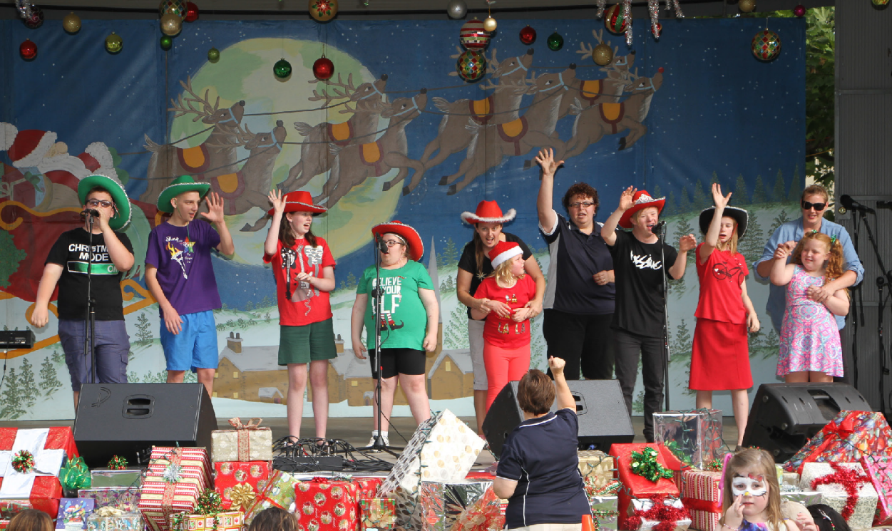

Our Action Plan

Focus Area 1: Developing positive community attitudes and behaviours
We want people with disability to feel welcome and included in Leeton Shire
We will do this by increasing community and staff awareness of disability with the following actions:
 | Action | Responsible Officer | Supported by | Timeframe | Performance Measures
1.1 | Develop a calendar of awareness days to support throughout the year e.g. International Day of People with Disability, Autism Awareness, Invisible disabilities, mental health etc | Community Development Coordinator | Library staff  Communications Coordinator | Completed by Dec 2023.  Ongoing | Calendar completed  Number of awareness campaigns conducted
1.2 | Include Disability Inclusion Action Plan in induction of all new staff | Manager People & Organisation Development | HR Officer  WHS, QA & Risk Officer | 2023-24 | DIAP in induction
1.3 | Provide targeted training for staff to improve awareness to people with disability, including mental illness | Manager People & Organisation Development | Relevant Managers and staff  Community Development Coordinator | Ongoing | Number of staff trained
1.4 | Investigate and implement a monitoring and reporting mechanism to ensure actions are achieved e.g. Project Control Groups, Pulse | Community Development Coordinator | Records & Governance Officer  Process & Project Performance Coordinator | 2022-23 | Monitoring mechanism established and being used
1.5 | Establish a photo library of images of people with disability enjoying working and living in Leeton | Community Development Coordinator | Communications Coordinator | 2023-24 | Photo library created
1.6 | Increase the visibility of people with disability in our publications and communications | Communications Coordinator | All staff responsible for creating publications  Community Development Coordinator | Ongoing | Number of images used
1.7 | Re-establish the Access and Inclusion Reference Group with a regular meeting schedule | Community Development Coordinator | Community Disability organisations | 2022-23 | Group formed  At least two meetings held per annum
1.8 | Provide local businesses with information on how to appropriately engage with people with disability (including mental illness) and how businesses could be more accessible and inclusive. Including safe use of the footpath | Community Development Coordinator | Economic & Community Development Manager  Business Chamber  Local businesses | 2023-24  Ongoing | Number of businesses contacted  Number of changes implemented

Focus Area 2: Creating liveable communities
We want people with disability to be able to access and use Council facilities, community events and move around the Shire with safety and ease.
We will do this by:
 | Action | Responsible Officer | Supported by | Timeframe | Performance Measures
2.1 | Conducting audits of Council facilities for compliance and develop a prioritised works program | Manager WHS, QA & Risk | Manager Planning, Building and Health  Risk and Quality Assurance Officer  Procurement and Building Services Coordinator  Group Manager Operations | 2023-24 | % of buildings audited  Works program developed
2.2 | Embedding engagement processes throughout Council projects or proposals, with a diverse range of disability representatives to ensure the needs of people with disabilities are met | Process & Project Performance Coordinator | Project Managers  Community Development Coordinator | Ongoing | Process developed  Number of engagement activities conducted
2.3 | Exploring opportunities to provide accessible park furniture & playground equipment | Manager Open Space & Recreation | Access and Inclusion Reference Group | Ongoing | Number of opportunities identified
2.4 | Construct a Changing Places Facility as part of the Sycamore St toilet upgrade | Procurement and Building Services Coordinator | Access and Inclusion Reference Group | 2023-24 | Changing places facility built
2.5 | Ensuring that the Active Transport Plan (previously PAMP) stays current and all shopping areas, priority routes and Council facilities are accessible linked | Road Safety Officer | Manager Roads and Drainage | 2023  Ongoing | Active Transport Plan adopted
2.6 | Developing a checklist to be used when planning all Council run community events | Community Development Coordinator | Events Officer | March 2023 | Checklist developed  Checklist used
2.7 | Ensuring, where all criteria have been met in line with the checklist, that all events are marketed and managed as accessible events | Events Officer | Community groups | Ongoing | Number of accessible events (maybe as a % of all events)
2.8 | Making a register of Council owned accessible venues available for public events | Events Officer | Community Development Coordinator | Ongoing | Register created
2.9 | Developing a fact sheet for event organisers, external to Council, to ensure an understanding of and compliance with disability requirements | Community Development Coordinator | Events Officer  Community groups | March 2023 | Fact sheet available on Council’s website
2.10 | Incorporating accessible pathway and kerb cut requirements in traffic management schemes | Manager Roads and Drainage | Group Manager Operations | Ongoing
2.11 | Auditing all disability parking and ensure compliance with AS 2890 and that they are in suitable locations throughout the Shire and then develop a prioritised works program | Manager Roads and Drainage | Access and Inclusion Reference Group  Road Safety Officer | 2023-24  Ongoing | Audit conducted  Prioritised works program developed  % of works program delivered
2.12 | Enforcing illegal use of disability parking spaces | Regulatory Services Coordinator | Manager Planning, Building and Health | Ongoing | Number of patrols  Number of infringements issued
2.13 | Advocating for disability access into shops | Community Development Coordinator | Access and Inclusion Reference Group  Leeton Business Chamber  Manager Planning, Building and Health | Ongoing | Number of improvements  Attending Business Chamber meetings
2.14 | Continuing to support of Narrandera-Leeton Community transport service (delivered by Narrandera Shire Council). | General Manager | Narrandera Shire Council | Ongoing | Community Transport Service continues
2.15 | Investigating options for access taxi service | Community Development Coordinator | Taxi operator  Access and Inclusion Reference Group | 2024 | Investigation conducted
2.16 | Complete the Roxy Theatre refurbishment to provide fully compliant accessibility for patrons and performers | General Manager | Procurement and Building Services Coordinator | 2023-24 | Roxy refurbishment complete and compliant

Focus Area 3: Supporting access to meaningful employment
We want people with disability to have access to meaningful employment in Leeton Shire.
We will do this by ensuring Council recruitment processes support people with disabilities by:
 | Action | Responsible Officer | Supported by | Timeframe | Performance Measures
3.1 | Review employment recruitment and selection processes to ensure they meet the needs of people with disability | Manager People & Organisation Development | Access and Inclusion Reference Group  Community Development Coordinator  All Managers | 2023-24 | Review completed
3.2 | Review the written procedure for employees to request workplace adjustments to enable equal access and inclusion for people with disability in the recruitment and selection process and at all stages of employment | Manager People & Organisation Development | Community Development Coordinator | 2023-24 | Review completed
3.3 | Continuing to facilitate opportunities for people with disability to work or volunteer with Council | Manager People & Organisation Development | All Managers  Local employment services | Ongoing | Number of people with disability working or volunteering at Council

Focus Area 4: Improving access to services
We want people with disability to be able to access the services they need.
We will do this by ensuring Council information is accessible by:
 | Action | Responsible Officer | Supported by | Timeframe | Performance Measures
4.1 | Monitoring Council’s website conforms to Web Content Accessibility Guidelines WCAG 2.1 Level AA | Communications Coordinator | IT Manager | Ongoing. Check annually | Website conforms to Web Content Accessibility Guidelines WCAG 2.1 Level AA.
4.2 | Developing a ‘tips sheet’ for staff when formatting documents to improve accessibility | Community Development Coordinator | Communications Coordinator | 2023-24 | Guidelines developed
4.3 | Providing information, relating to Council’s services and facilities, in formats that are accessible to people with a disability | Customer Service & Governance Coordinator | Communications Coordinator  Community Development Coordinator  Access and Inclusion Reference Group | Ongoing | Number of pieces of information provided in different formats
4.4 | Reviewing feedback mechanisms to ensure they are useable by people with a wide range of disabilities | Customer Service & Governance Coordinator | Community Development Coordinator  Access and Inclusion Reference Group | Ongoing | Review conducted  Number of changes made
4.5 | Developing a process that allows customers to provide verbal as well as written feedback | Customer Service & Governance Coordinator | Community Development Coordinator  Access and Inclusion Reference Group | 2023-24 | Procedure in place
4.6 | Working with the Business Chamber and Leeton Connect to establish and maintain the Digital Hub – Leeton Living – which will list local disability service providers | Community Development Coordinator | Leeton Business Chamber  Leeton Connect | 2022-23  Ongoing | Digital Hub has list of local disability service providers
4.7 | Installing hearing augmentation in the Council Chambers | Procurement and Building Services Coordinator | IT Manager | 2024-25 | Hearing augmentation installed

Delivering the DIAP

Governance
The General Manager and Senior Management Team will sponsor and promote the DIAP. Elected Councillors will assess progress of the DIAP thought Delivery Plan reporting and the Annual Report.

Integration
The actions in this plan will become part of our Delivery Program and Operational Plan and help us to deliver the Community Strategic Plan.

Monitoring and Evaluation
An evaluation framework with performance indicators has been developed to measure change. Data will be collected and reported throughout the implementation of the DIAP.
Regular meetings with the Disability Inclusion Reference Group will also monitor and evaluate progress.

Reporting
Progress towards delivering the actions in the DIAP will be formally reported as part of our annual reporting processes. We will prepare and submit reports to the NSW Disability Council as required.
- The Disability Inclusion Action Plan will be made publicly available following adoption by Council
- A copy will be sent to the NSW Disability Council as required by the NSW Disability Inclusion Bill 2014
- Implementation of the Disability Inclusion Action Plan will be monitored, evaluated annually and reported upon in Council’s Annual Report
- The DIAP will become a regular agenda item on the Disability Inclusion Reference Group agenda
- The section of Council’s Annual Report relating to the implementation of the plan will be provided to the Minister for Disability Services, as required by the NSW Disability Inclusion Bill (2014)
- The Disability Inclusion Action Plan will be reviewed and updated every four years

Ongoing Engagement and Review
We will talk with the community regularly to check that the priorities in the Plan are still the same and make changes to the DIAP where we need to, including the Disability Inclusion Reference Group.

Funding the DIAP
Some actions in the DIAP are about continuing to do what we do well, and others are about improving the way we do things. Many actions will not cost additional money but require us to do things differently.
However, some actions in the DIAP will require additional funds to build something or upgrade an existing facility or service. The money to do this work will be allocated through the annual budget process where possible. At times we may apply for funding from external sources to help achieve the actions in the DIAP.

Relationships to Council’s other plans
The Disability Inclusion Action Plan is integrated into Council’s Integrated Planning and Reporting Framework. Actions are aligned into key objectives and outcomes are reported within the Council’s Annual Report.
The DIAP should be viewed in conjunction with the following Council plans:
- Leeton Shire Council Community Strategic Plan – Liveable Leeton 2035
- Leeton Shire Council Delivery and Operational Plans
- The Pedestrian Access and Mobility Plan and Bicycle Plan (to be replaced by the Active Transport Plan)
- Leeton Shire Council Workforce Plan
- Leeton Shire Council Playground Strategy 2017-2032
- Ageing Well Strategy 2021-2025
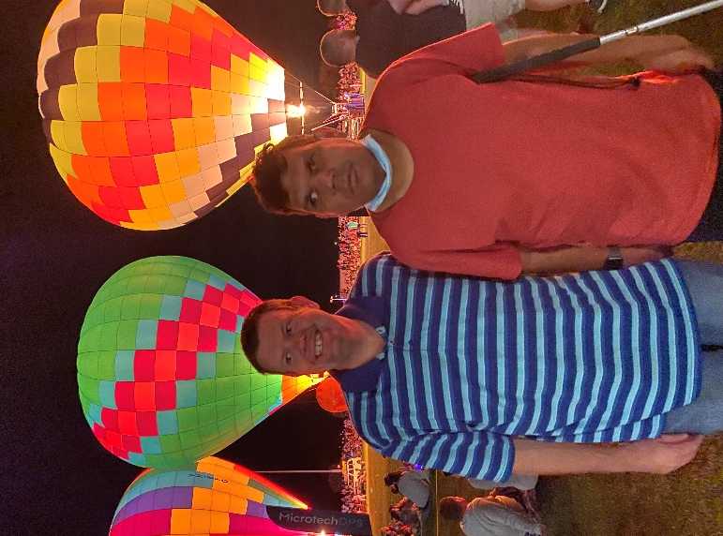
Photo courtesy of Kurrajong

Laws and Systems
People with disability, their families and carers have the same rights as all people to access services and facilities. These rights are part of State and Commonwealth policy and legislation which make it unlawful to discriminate against a person with disability.
The context for all NSW disability inclusion action plans is embedded in the below conventions and laws.
International
  - United Nations Convention on Rights of Persons with a Disability (2007)
Australian
Federal
  - Disability Discrimination Act 1992 (Commonwealth)
  - Disability Services Act 1986 (Commonwealth)
  - National Disability Insurance Scheme Act 2013 (Commonwealth)
  - National Disability Insurance Scheme
State
  - Anti-discrimination Act 1997 (NSW)
  - Disability Inclusion Act 2014 (NSW)
Additional legislation and standards include:
  - The Building Code of Australia (BCA) that provides a set of minimum requirements for new buildings and renovations
  - The Access to Premises Standard under the Disability Discrimination Act (DDA)
  - Australian Standards on access and mobility for people with disability i.e., AS1428 buildings and facilities, AS1735.7 stairway lifts, AS1735.12 escalators and moving walks, AS2890.1 off-street parking, AS2890.5 on-street parking
  - Other DDA standards which may have application including Accessible Public Transport, Employment and Education

